Task 1

1. Create a new management group

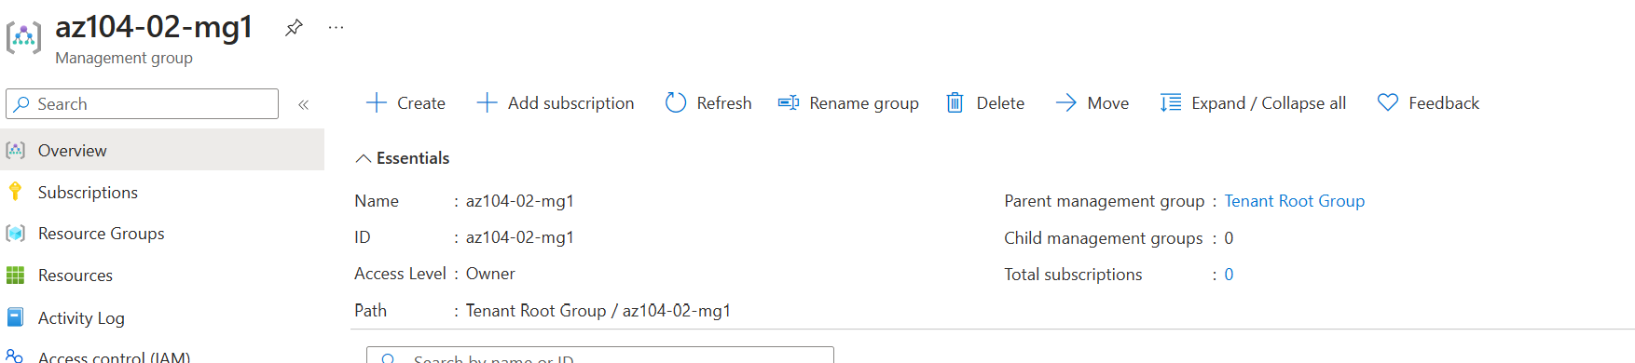

1. Set a subscription plan to group

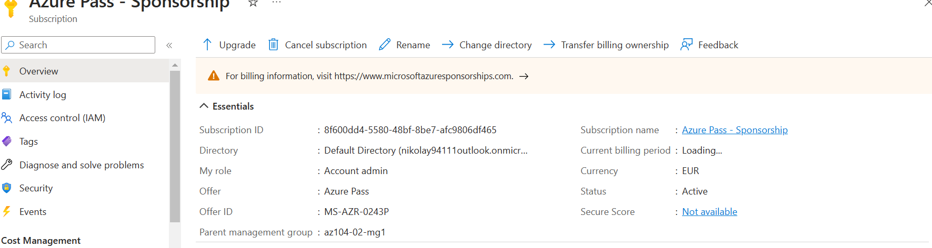

1. Set a custom role definition

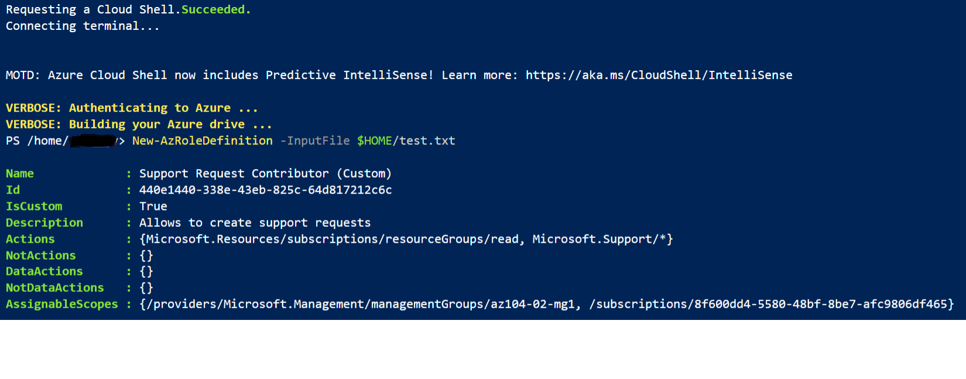

1. Crete a new user

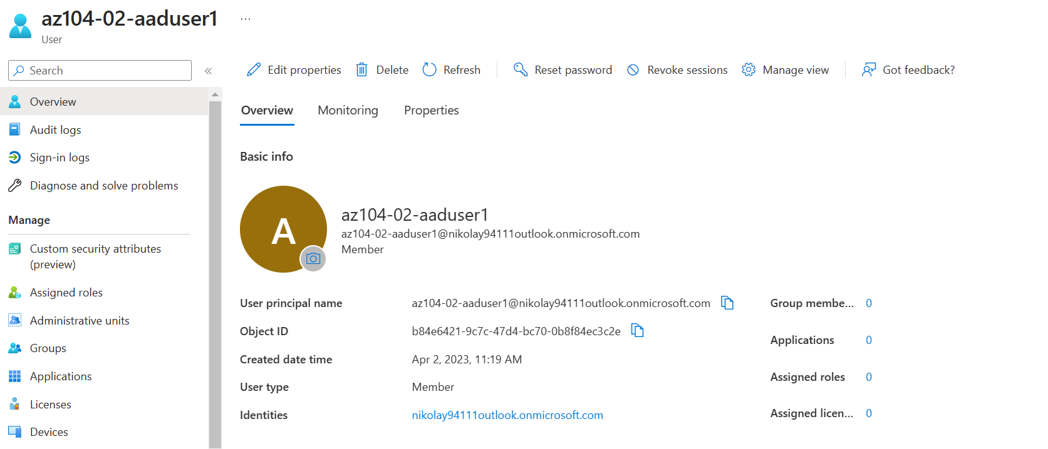

1. Add role assignment



1. Check user resource group

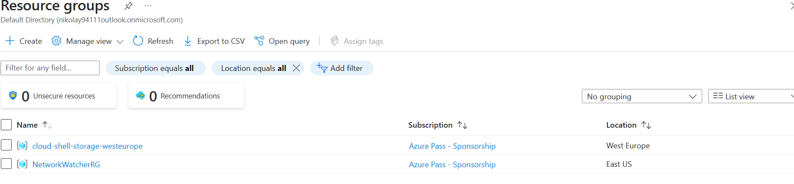

1. Check user all resources

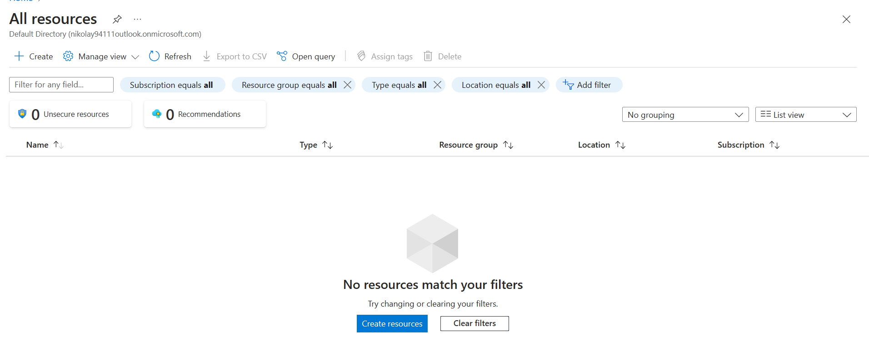

1. Create a help and support request

